# ITA  Municipal Merge Analysis

## **1. Introduction**

### **Overview**

#### This document provides an analysis of address points in ITA that fall within the boundaries of various ITA  municipalities. Using advanced spatial analysis/SpatialFilter and  HEX Encoded OGC WKB conversion, we filtered and visualized the data to understand the distribution of these points relative to municipal borders. municipalities were filtered to only include instances where feature_id.total_count > 1.

### **Purpose**

#### The primary goal is to identify all address points that intersect with the boundaries of 301 municipalities, providing a detailed insight into their spatial relationships and the first stage of understanding changes in muni and references pre and post merge.

## 2.  **Analysis**

### **Summary of Findings**

* **Total Municipalities Analyzed:** **301**
* **Total Address Points Analyzed:** **25,674,395**
* **Address Points within Municipal Boundaries:** **553,968**

### **Visualization**

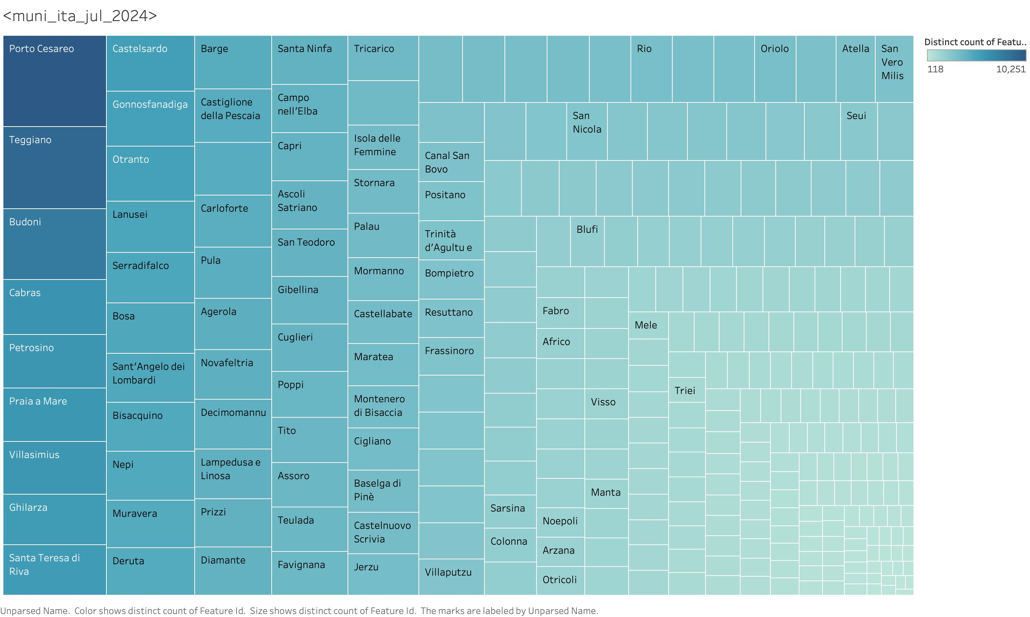

### **Point Density Map**

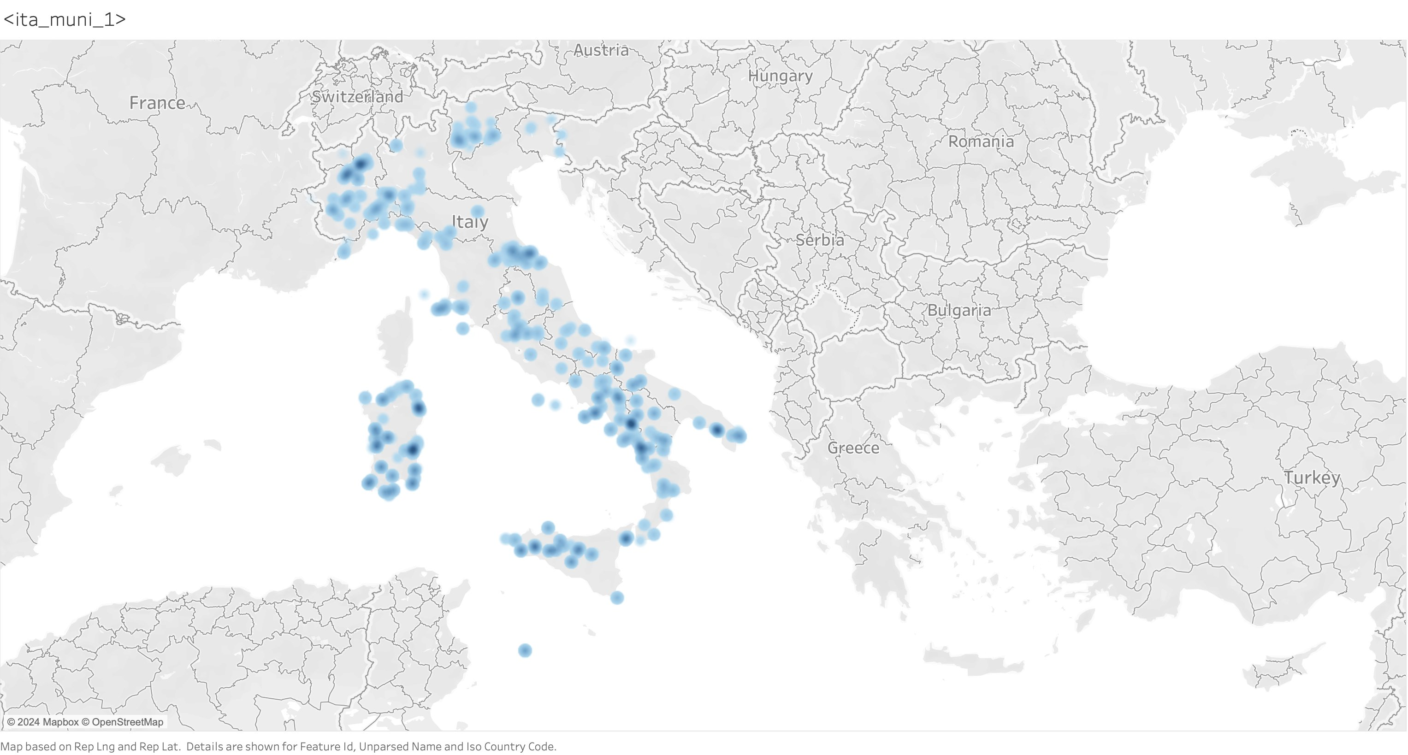

### **Statistical Analysis**

* **Top 10 Municipalities by Address Points:**

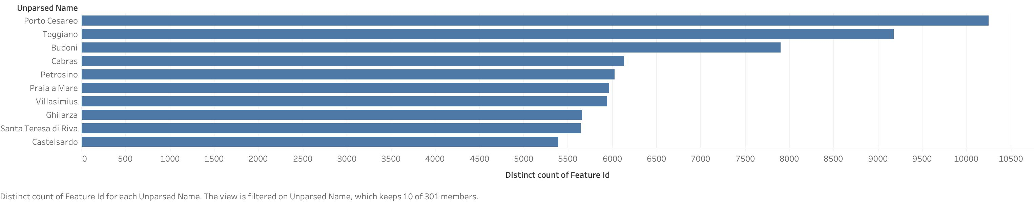

## **3. Data Sources**

### **Address Points Data**

* **Dataset Name:** jq_sept_2024.Address

### **Municipal Boundaries Data**

* **Dataset Name:** ita_sept_2024.territory (filtered result of municipalities)

## **3. Methodology**

### **Spatial Relationship: Intersect**

### Using FME's **SpatialFilter** transformer, we determined which address points intersect with the municipal boundaries.

### **Workflow Steps:**

1. **Data Input:** Loaded both address points and municipality boundary datasets.
2. **Spatial Filtering:** Applied the **SpatialFilter** transformer.
   * **Candidate:** Address Points
   * **Filter:** Municipal Boundaries
   * **Spatial Relationship**: Intersects
3. **Output Generation:** Filtered address points were exported to a CSV file for further analysis.

### **Data Validation**

* **Geometry Conversion:** Converting address points from HEX encoded WKB and municipalities from WKT to FME binary code for Spatial relation processing
* **Geometry Checks:** Ensured that all address points had valid geometry before processing.
* **Spatial Accuracy:** Verified that all municipalities had correctly defined boundaries.

## **5. Conclusions & Recommendations**

### **Key Insights**

### **Next Steps**

* **Further Analysis:** Perform further EDA on address points within municipalities to discover changes/relationships with references and naming after municipalities are merged in upcoming weeks.

## **6. Appendices**

### **Appendix A: Methodology Details**

* **SpatialRelator Configuration:**

**Transformer Name:** SpatialFilter

**Filter Type:** Multiple Filters

**Pass Criteria:** Pass Against One Filter ‘

**Support Mode:** Supports Aggregates

**Spatial Predicates to Test:** “Filter OGC-Intersects Candidate”

**Use Bounding Box:** No

**Curve Boundary Rule:** Default Rule

**Accumulation Mode:** Merge Filter

**Conflict Resolution:** Use Candidate

**Output Attribute Name:**

**Predicate:** _predicate

* **Validation Scripts:**

## **7. References**

* **FME Documentation:**